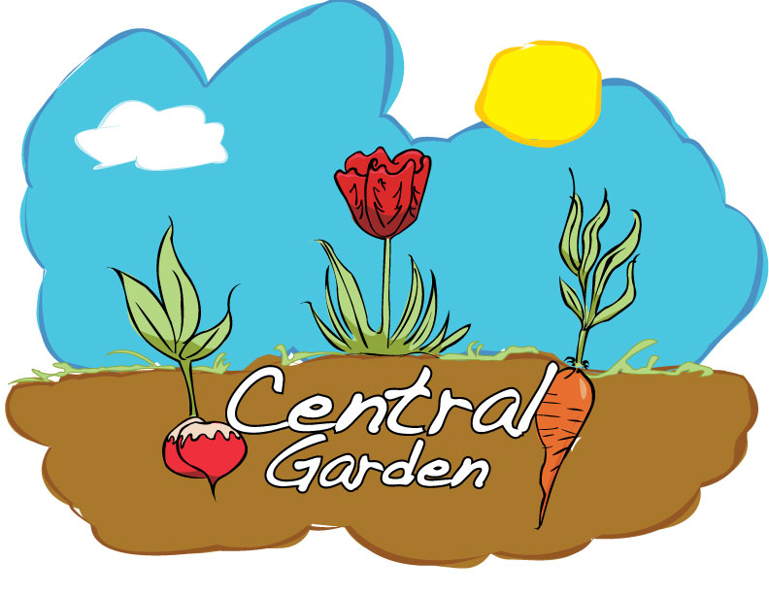
Central Garden
Liberty Memorial Central
Middle School
1400 Massachusetts St
Lawrence, KS 66044

Summer Program
May 31 – August 11
Monday, Tuesday, Wednesday, Thursday 9a – 11a
**Students that have completed 6th grade and are interested in helping at the Cottin’s Hardware Farmer’s Market on Thursdays 3:00-6:30p will be assigned the first week of summer program.**

Student Information:
Name: |  | Date of Birth:
2016-17 Grade: | Phone: | Email:
Street Address:
City: | State: | Zip code:
Parent/Caregiver Information:
Name: | Home Phone:
Email: | Work/Cell Phone:
Name: | Home Phone:
Email: | Work/Cell Phone:
Emergency Contact Name: | Phone:
Emergency Contact Name: | Phone:

Student Agreement:
I understand that in participating in the Central Garden I will be expected to demonstrate self-control, trustworthiness, optimism, motivation, and preparedness.

Student Signature Date

Parent/Caregiver’s Release:
I give my permission for my student to participate in the Central Garden program at Liberty Memorial Central Middle School. I am aware that if my student will be absent, it is my family’s responsibility to inform Garden coordinators. I understand that if my student does not comply with the student agreement, they may be dismissed from the program. I am also aware that if I do not want photographs of my student used in relation to the Central Garden, it is my responsibility to inform Garden Coordinators.

Parent/Caregiver’s Signature Date

