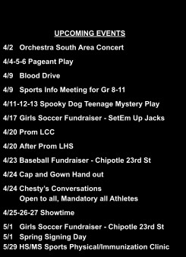

MONTHLY NEWSLETTER FOR LAWRENCE HIGH SCHOOL LAWRENCE, KANSAS

APRIL, 2024

**A Message From the Principal**

Dear Parents and Guardians,

As we approach the final quarter of the academic year, we are thrilled to announce our upcoming events for students. We cordially invite you and your student(s) to participate in our athletics and activities and extend your unwavering support to our students as we conclude the school year on a high note.

It’s a GREAT day to be a Lion! - Quentin Rials, Principal

#### Sports Physical & Immunization Clinic for LPS High School and Middle School Athletes

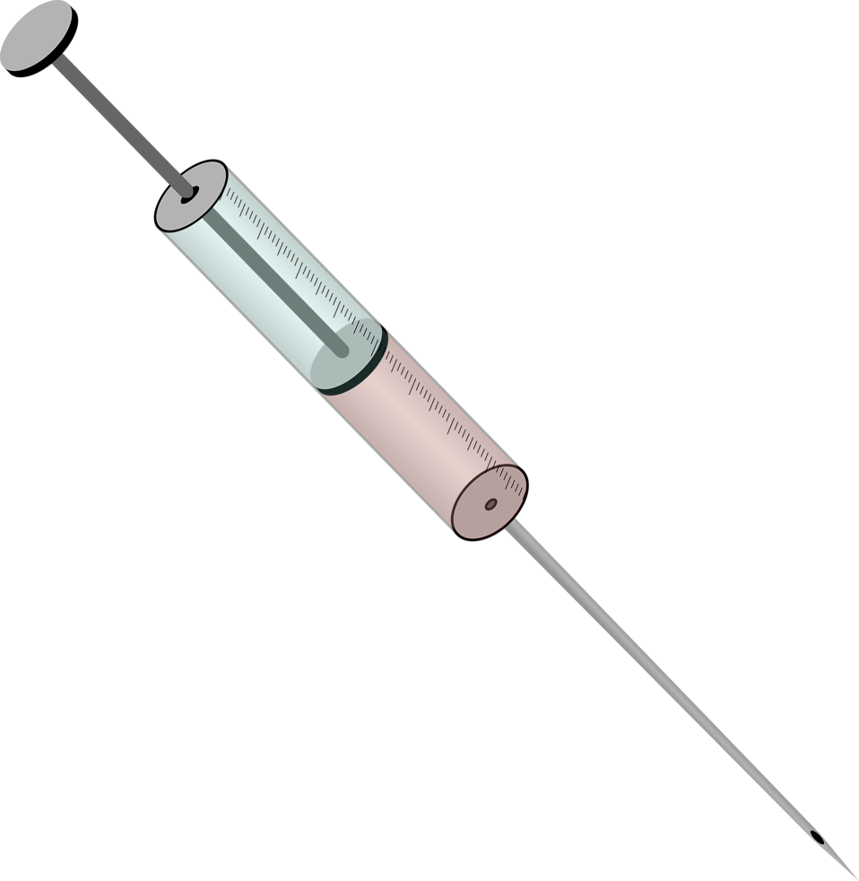LMH Health will be at LHS on Wednesday, May 29th to give sports physicals for interested LPS High School and Middle School athletes. The cost is $25 (cash or check). No Appointments. Doors will open at 6:00 and close promptly at 7:00 pm. Half of the cost will be donated to the district sports medicine budget.

Also at the event, Lawrence Douglas County Public Health will offer required immunization for students 7th grade - 11th grade including Tdap, Meningococcal, and Hepatitis A vaccines.

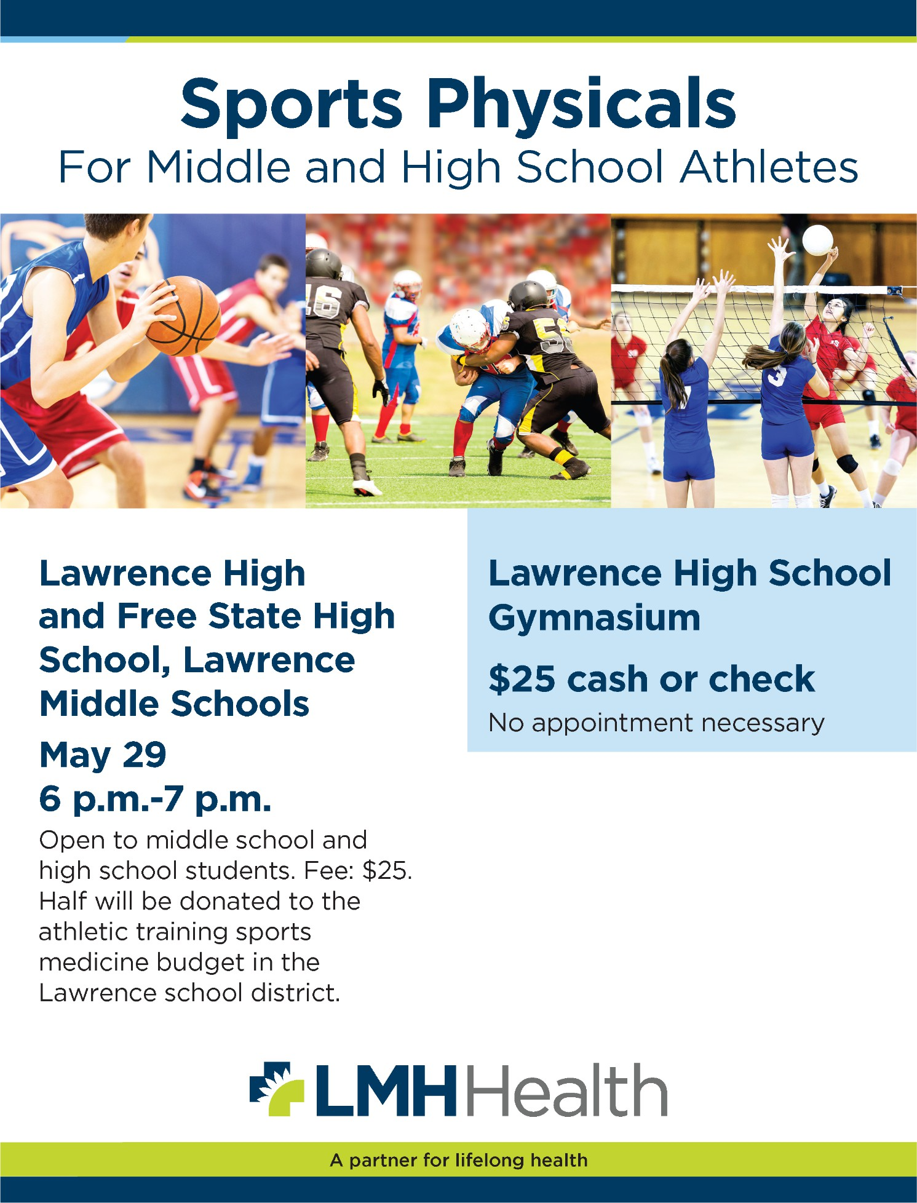

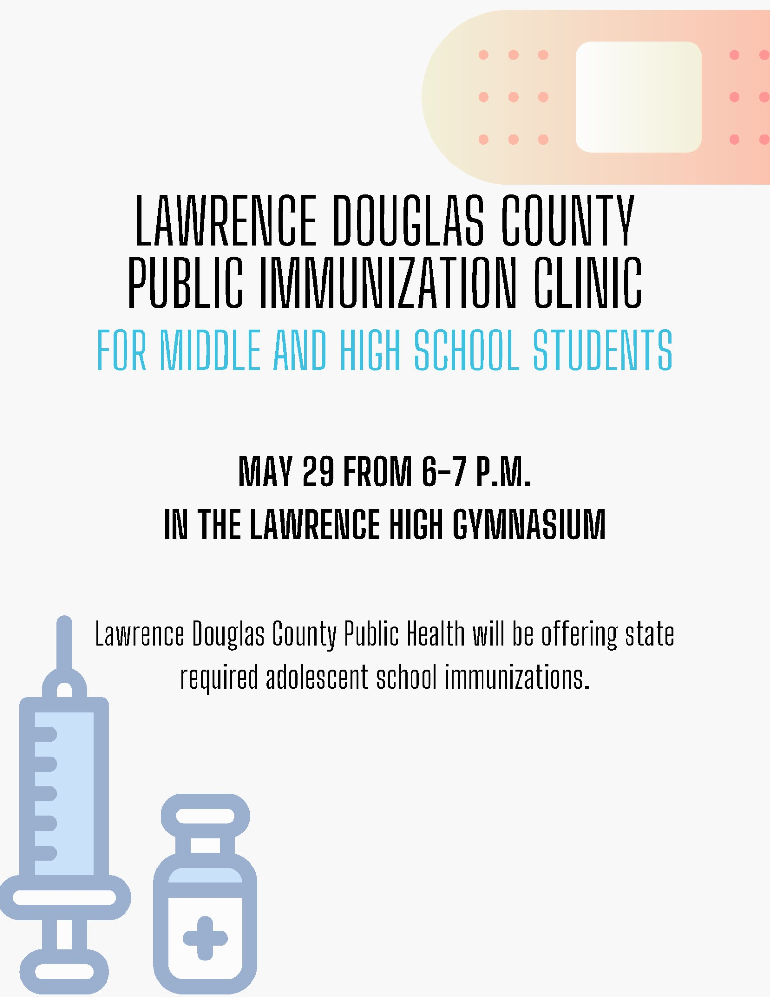

Alums and alumni families, for the first time in over 40 years, LHS Speech and Debate needs to raise money to put the program on a sound financial footing, and to attend the NSDA national tournament this summer.

Recent years of budget cuts and declining enrollment have taken a toll, and we are turning to you to keep our program moving forward. Please consider donating so that the LHS students of today and tomorrow have the same opportunities LHS has always been able to provide.

If you have any questions, please message Coach Jeff Plinsky at [jplinsky@usd497.org](mailto:jplinsky@usd497.org). Please also share this link on your social media so that other alums see it. [https://payments.efundsforschools.com/.../01DEBATE23_24](https://payments.efundsforschools.com/fundraising/districts/55379/campaigns/01DEBATE23_24?fbclid=IwAR1NT4n2CIabLtB4Q3z8LEDD_zaxK-Bp0EtPWFtxPTCvR0bvExrXIVzh4ZE)

April Is the month f State Testing. The 11th graders are currently completing t_beir single assessment in science. 10th grade w II start ELA the first week of April followed by Math

i the next week. The third week is make-up. 9th and 12th radars do not take sta e assessments. These assessments

are-mportant but, for so re son, they are not universally taken_seriously. Please encourage your child to charge their iPads. go to class. and complete their assessments.

* April 1st: Annual Student Registration opens. Please complete this for your household and update your demographics.
* April 24th: Capand Gown Handouts*

*Seniors and Seniors Family: Students will only receive their cap and gown if they are passing the final required credits and they are not at risk (credit-wise) of graduating.

Ah. Fourth Quarter. Spring. The sun is shining. The birds are chirping. Flowers are blooming. Yet, we have eight more weeks of school. Students, especially Seniors, start to lose focus/motivation--easily distracted by the green trees and lawns. This is where great impulse control skills and willpower make a difference. If you haven't been checking on your student's grades, now is a great time to start.

All Juniors were given the opportunity to ta et e ACT provided by the state at the end of February. Those ACT scores are now available for the ACTwe took back in February. Please log into your mv.act.org_ account to access your scores. Having trouble viewing your scores or accessing your account? Submit a contact form to ACT by clicking this link.

Here are some OR codes- In case you want to include them as well.

We had a great completion rate for our course selections. All but about 50 students had course selections with over five credits requested. The four of us worked really hard to complete this andtried to meet with as many students as we could. That being said, each of us probably had about 10-15 studentstha we completed their course selections and it was not student choice at all.

we are at the place In scheduling for next year where we are not changing course selection. This does not mean that a student can't change what they inputted but It does mean that we will notbemaking the change until later this semester or, work case scenario, this Summer. If course requests need to be changed, please come speak to us and we will make ote of it--

Registration for the May 2024 Ex mis CLOSED. You can still cancel the exams up to May 1st.The College Board charges a $40 cancelation fee.

AP Exam are late this year starting on Monday, May 6th. Schedule including locations will besent to students In April.

We receive several summer opportunities every year. It is hard to promote them all. We have at least four leadership style opportunities:LMH Health LeadershiP- AcademyJ RYLA. YCLI. and Boy &Girls State. They are all looking for a different type of student. If you are interested, reach out to one of your counselors (most of them require our recommendation). Please act fast--their deadlines

are coming soon!!





#### ACTIVITIES OFFICE

[Dr. Elaina Honas](mailto:elaina.honas@usd497.org), Assistant Principal/Activities Director [Dr. David Ruis](mailto:david.ruis@usd497.org), Activities Secretary

**Follow us on Twitter @activities_LHS**

###### Dates to Know:

April 3 Senior Speaker Auditions in the Learning Commons (times will be provided to those who sign up)

April 4-6 Spring Play at 7 pm April 11-13 Spring Play at 7 pm

April 15 - Senior Prom tickets go on sale (cost $15)

*Guest Forms available on April 8th and due back on April 17th by noon April 20th Senior Prom at Lawrence Country Club 8-10 pm

April 24 Cap and Gown Distribution at 1:10 pm in the Learning Commons April 25-27 Showtime at 7:30 pm

###### Senior Information:

* Check your email for information regarding Senior Exemptions
  + This can also be found on the LHS website under activities
* Senior Newsletter sent out via email
  + This information can also be found on the LHS website under activities
* There is a $40 graduation fee that will be on your student account that includes the cost for the diploma cover/diploma/cap/gown/tassel.
* LHS Graduation will be held on May 22nd

**Students who do not have **all** of their required credits **will not be able to participate** in the graduation ceremony.

#### STUDENT CLUBS

CAN WE TALK AND SAFE CLUBS - meetings will be in room 203 on Wednesdays @ 1:25 pm.

Snacks will be provided & new members are always welcome.

Got Questions? See Ms. Thomas in Student Services or email her at [lthomas@usd497.org](mailto:lthomas@usd497.org)

YOUNG WOMEN OF COLOR (YWOC) - Meeting

times will be announced. Check out our GroupMe for the time & place. Got Questions?

See Ms. Thomas in Student Services or email her at [lthomas@usd497.org](mailto:lthomas@usd497.org)

PRIDE CLUB - Meetings are held Tuesdays from 3:15 pm to 4:00 pm in room 328. Open to everyone.

FFA CLUB- Future Farmers of America meets on Wednesdays in room 172. Join us!



#### Sophomores, Juniors, and Seniors

Sophomores, Juniors, and Seniors can now apply for the LMH Leadership Academy for this summer as long as they are 16 by June 1st, 2024. It's a paid internship that lasts for 8 weeks over the summer with either Lawrence Memorial Hospital or this year with the City of Lawrence. Applications are due by May 8th. Here is the link and the flier.

[LMH Leadership Academy](https://www.lmh.org/lmh-health-leadership-academy/application-instructions/)

# Want to volunteer?

Sign up [here](https://www.signupgenius.com/go/4090A44A9AA2BA46-48765366-mudvolleyball)

SAVE THE DATE MAY 5

Want to play?

ROSTERS AVAILABLE APRIL 15

See Ms. Leuschen or Ms. Scarbrough for questions

##### PLEASE CALL 2 HOURS IN ADVANCE CLASSES MAY BE OUTSIDE

***Call the Attendance Line at 785-330-4968 or email*** [***lhsattendance@usd497.org***](mailto:lhsattendance@usd497.org) ***to report an absence or check a student out during the school day***

##### ATTENDANCE

🔴Please allow a minimum of two hours to excuse students during the school day

* Students will be released by their teacher only when notified by a pass from the office

🔴Only parent(s)/legal guardian(s) listed in PowerSchool may excuse students

* Students may not excuse themselves or check themselves out

🔴Both voicemail\email are monitored continuously during business hours - Please leave a Message!

#### Annual Prom Dress & Formal Wear Giveaway

##### SATURDAY APRIL 6TH FROM 10 AM-2 PM!

The giveaway is for high school students looking for an opportunity to refresh their formal wear without breaking the bank. We have gently used & new dresses, suits, shirts, skirts, slacks, shoes, ties & accessories.

Got items to donate? Want to volunteer?

Contact Ms. Thomas at 785-330-4631 at Lawrence High School.

"Every day our local area hospitals need at least 600 units of blood. Currently, there is a severe shortage of blood and with there being no substitute for blood, blood donations are the only way to help those in need. By donating blood you can save 3 lives. Lawrence High Blood Drive Committee students have organized the LHS Spring 2024 Blood Drive in collaboration with the Community Blood Center of Kansas City. The Blood Drive will be held on **Tuesday, April 9th, 2024** between 8:30 AM and 2:00 PM at the West Gym.

Students and community members can sign up using this link: <https://donate.savealifenow.org/donor/schedules/drive_schedule/79064>

Students who are 16 or 17 will need to have a parental consent form signed. For more information and the consent forms, contact Anitha Subramanian, Room 141

## ANNOUNCEMENTS

LHS Student Media Classes and Room 308 Productions present student announcements every Monday and Friday via the Room 308 Productions YouTube Channel [**Room 308 Productions YouTube Channel**](https://www.youtube.com/channel/UC8iDVTG1gnc-9gQdDQpC3tQ)

## THIS WEEK AT LHS

Don’t miss out on events and activities at Lawrence High School when you keep up with our weekly calendar, <https://lhsbudget.com/category/this-week-at-lhs/>

## LHS SITE COUNCIL

*Next Site Council Meeting:* Done for the year. See you in August!

## LHS STUDENT PUBLICATIONS

Would you like to see your business featured in our nationally-recognized student publications? Sign on as an advertiser or supporter. Details are listed here: <https://lhsbudget.com/about/advertise/>. Or go directly to our donation link: <https://payments.efundsforschools.com/fundraising/districts/55379/campaigns/LHSJRNSM23>



**Plant Sale April 3rd** CTE Expo Special Event 5:00 - 7:00 pm At LHS

Can't make it? Email Ms. Landers for after-school greenhouse sales times/days

## LION’S PRIDE PTO

Parent/Guardian/Teacher Organization for Lawrence High School -Everyone Welcome!

**After Prom!** is April 20th and provides a fun safe event free to all LHS seniors and one guest. PTO along with Parents and Guardians create a carnival-type atmosphere with food, games, inflatables, and prizes!This event is unique to Lawrence High School and relies on the support of LHS families and the community. If you can support the event, please send or deliver to the school a check made out to Lions Pride After Prom or donate here: <https://www.paypal.com/paypalme/LHSAfterProm?country.x=US&locale.x=en_US>

We also need volunteers on April 20th and food donations! You can sign up here to help: <https://www.signupgenius.com/go/10C0A4BAEAD28A4F49-48815870-volunteers>

**PTO Scholarships** - The Lions Pride Scholarship committee will present six $500 scholarships at the Senior Scholarship Night on May 1st.

**LHS Merchandise will be selling 4/25**

**at the track meet, baseball game and womens soccer games! Meanwhile, you can**

**shop online at the link below.**

**All proceeds support LHS Staff and Students!**



<https://lionspride-108327.square.site/>

**Questions about anything PTO-related, you can reach us at** [lawrencehighlionspride@gmail.com](mailto:lawrencehighlionspride@gmail.com)

LHS Lions Pride PTO Committee Jamie McNally - Chair

Jessica Wolleson - Treasurer Nicole Etzel - Merchandise

Connie Grimes - Secretary/Appreciation Amy Phalen - Co-Chair |



**Talk to a Counselor…located in Student Services**

A-E Jen Hare

F-K Amy Brown L-Q Libby Martin

R-Z Michele Franz

# ATHLETIC OFFICE

[Mike Gillman](mailto:mgillman@usd497.org), CAA

Assistant Principal/Athletic Director

[Emily Cates](mailto:ecates@usd497.org) Athletic Secretary

Ashley Kampfer, LMH Health Athletic Trainer

### Head Coach Contact Info



|  |  |  |
| --- | --- | --- |
| Baseball-Boys | Stoll, Brad | [bstoll@usd497.org](mailto:bstoll@usd497.org) |
| Basketball-boys | Wood, Nick | [nwood@usd497.org](mailto:nwood@usd497.org) |
| Basketball-Girls | Dickson, Jeff | [jdickson@usd497.org](mailto:jdickson@usd497.org) |
| Bowling-Boys, Girls, Unified | Burton, Lary | [lburton@usd497.org](mailto:lburton@usd497.org) |
| Boys, Girls | Moos, John | [jmoos@usd497.org](mailto:jmoos@usd497.org) |
| Cross Country - Boys, Girls | Morgison, Kyle | [kyle.morgison@usd497.org](mailto:kyle.morgison@usd497.org) |
| Football-Boys | Bowen, Clint | [clint.bowen@usd497.org](mailto:clint.bowen@usd497.org) |
| Gymnastics-Girls | Gonzales, Alexis | [agonzale@usd497.org](mailto:agonzale@usd497.org) |
| Soccer-Boys, Girls | Comparato, Joe | [joe.comparato@usd497.org](mailto:joe.comparato@usd497.org) |
| Softball-Girls | Byrn, Mike | [michael.byrn@usd497.org](mailto:michael.byrn@usd497.org) |
| Spirit Squads-Coed | Wedd, Gwen | [gwedd@usd497.org](mailto:gwedd@usd497.org) |
| Swim/Dive-Boys, Girls | Weber, Elle | [eweber@usd497.org](mailto:eweber@usd497.org) |
| Tennis-Boys, Girls | Marshall, Chris | [gcmarsha@usd497.org](mailto:gcmarsha@usd497.org) |
| Track-Boys, Girls | Trowbridge, Audrey | [apope@usd497.org](mailto:apope@usd497.org) |
| Volleyball-Girls | Vacant |  |
| Wrestling-Boys | Naughton, Patrick | [pnaughto@usd497.org](mailto:pnaughto@usd497.org) |
| Wrestling-Girls | Springer, Carl | [carl.springer@usd497.org](mailto:carl.springer@usd497.org) |

##### DATES TO KNOW

April 1 24/25 Spirit Squad Parent Meeting

April 9 24/25 Athlete/Parent Info Night - Incoming Freshmen Welcome April 24 Chesty Conversations (mandatory for all athletes, all seasons)

May 1 Spring Signing Date - 1:45 pm Main Gym

* *Physicals taken prior to 5/1 are not accepted for 24/25*
* *Only the newest version (3.2024) of the KSHSAA PPE will be accepted*
* NEW only page 4 is required

May 8 Chesty Conversations (mandatory for all athletes, all seasons)

May 29 Sports Physical and Immunizations Clinics - 6:00 pm - 7:00 pm_Main Gym

June 2 First day to UPLOAD a physical for 2024-2025 *(must be dated after 5/1/24 per the KSHSAA)*

June 5 Athletic Office CLOSES for the summer



|  |  |  |
| --- | --- | --- |
| *April 17* | *Girls Soccer - SetEm Up Jacks* | *4:00 pm - 9:00 pm* |
| *April 23* | *Baseball - Chipotle 23rd Street* | *5:00 pm - 9:00 pm* |
| *May 1* | *Girls Soccer- Chipotle 23rd Street* | *5:00 pm - 9:00 pm* |

*In order to promote a sense of community, belonging, and respect the LHS Athletic Department is requiring all athletes to attend* ***CHESTY LIONS CONVERSATIONS*** *sessions held once a month.*

*They will be held at 1:45 pm in the Auditorium.*

***All athletes, all seasons, should attend each session.***

*A different subject will be presented and discussed at each session.*

*Athletes unable to attend should notify their head coach.*

##### SPORTS REGISTRATION

All registration and forms submission for athletics is completed on the website [www.aktivate.com](http://www.aktivate.com/).

* Forms may not be submitted in person to the athletic office, a coach, or summer coaching staff
* Physicals must be dated on or after May 1 of the previous school year to be valid

**Current Athletes:** If your student already has an Aktivate profile **do not** create a new profile in [AKTIVATE](http://www.aktivate.com/) for 24-25. Log in, select the athlete, and select 24-25 in the ‘Select Year/Sport’ drop-down menu. Be sure to review all previously entered information and make sure it is still correct. First-time LHS athletes/managers must complete a profile before uploading forms.

**Incoming Freshmen**: Do **NOT** complete a profile until June 2. Aktivate rolls all the grade levels up on June 1 and your grade level would then be incorrect for 24/25



##### SPORTS FORMS SUBMISSION

All athletic forms must be submitted ONLINE at [www.aktivate.com](http://www.aktivate.com/). Registration paperwork may not be submitted in person to the Athletic Office, Main Office, Coaches, or Summer Coaching Staff. First-time athletes must complete a profile before uploading the required forms.

##### SCHEDULES AND ATHLETICS INFORMATION

Lawrence High Athletics Department Website [www.lawrenceathletics.org](http://www.lawrenceathletics.org/) The place to go for sports info!!

Schedules & Cancellation Info [www.sunflowerleague.org](http://www.sunflowerleague.org/) Official schedules for LHS Athletics!

Updated M-F 8:00 am-3:00 pm

Follow us on Twitter @LawHS_Athletics

It’s time to start thinking about scheduling your physical for 2024-2025. Physicals must be dated *May 1, 2024, or after* to be valid for next year.



LHS Gear is Available on BSN Sports Check out the Lawrence Lions School Store* open 24/7 on BSN Sports

A percentage of sales returns to LHS as a rebate

*Find the design that’s right for you! Find your new favorite shirt! Customizable LHS T-shirts, Fleece, Accessories, Wall Stickers, and MORE Shop from brands like The North Face, Under Armour, Nike, and other well-known brands. Watch* [*LawrenceAthletics.org*](http://lawrenceathletics.org/) *& Twitter for sport-specific gear announcements and links*

### HEALTH OFFICE

**Dental Screens:** All students are offered a Dental screening on Monday, April 29th. Dental hygienists from The Douglas County Heartland/Healthy Futures will come to the school to screen students. It takes a few minutes for a visual screen by a dental hygienist.

Please complete the 'OPT OUT' if you do not want your student to be screened. This is a free health screen offered by Healthy Futures.

**Dental opt out** [**https://docs.google.com/forms/d/1LZQzpaPFzBlrqD4cwusLFujpzUb_Im7bvPJ6rwsmKzk/viewform?edit_requeste**](https://docs.google.com/forms/d/1LZQzpaPFzBlrqD4cwusLFujpzUb_Im7bvPJ6rwsmKzk/viewform?edit_requested=true)[**d=true**](https://docs.google.com/forms/d/1LZQzpaPFzBlrqD4cwusLFujpzUb_Im7bvPJ6rwsmKzk/viewform?edit_requested=true)

**Sports Physicals:** Please see the information on sports physicals that will be offered at LHS May 29th. The health department will be at the school for Immunizations also. Students needing updated Tdap, Meningococcal, Hepatitis A, and or HPV (human papillomavirus) can receive them on May 29th.

###### Update on immunizations for 2023-2024 school year

* Covid Protocol: USD497 Protocol
* Meningococcal: 2 doses -All students should have a record of at least one dose of the Meningococcal vaccine usually given at 11-12 years of age and a second dose at 11th grade.
* Tdap: Tetanus, Diphtheria, Pertussis: One dose -usually is given in middle school but if your student missed this dose, please make sure they have this before school starts.
* Hepatitis A: 2 doses are required.

**Recommended**: yearly Influenza vaccine; HPV (Human Papillomavirus) 2 doses if given before age 15; otherwise 3 doses.

***Please keep your child home if they are ill!***

For more information about influenza go to the following link:

[**https://www.cdc.gov/flu/treatment/takingcare.htm#whatshould**](https://www.cdc.gov/flu/treatment/takingcare.htm#whatshould)

For information about COVID please visit the LPS website:

[**https://www.usd497.org/Page/14886**](https://www.usd497.org/Page/14886)

**Asthma Inhalers:** High School students can and should keep their asthma inhalers with them at all times. Please contact the nurse if you would like the inhalers kept only in the health office.

**Epi Pens:** Please make sure the nurse knows that your student is keeping an EPI Pen with them in their backpack. If they have a need for emergency EPI PENS, they should have one with them at all times. Please notify the nurse about any changes or a new diagnosis so other staff are aware and can help in an emergency situation.

**Seizures**: Please notify the nurse if your student has been diagnosed with a seizure condition and has emergency medication to keep at school.

**Diabetes**: Please notify the nurse of updated diabetes medications and changes. Back-up snacks and medication can be kept in the health office.

**OTC**/Over-the-counter headache and pain medication (such as acetaminophen and/or ibuprofen, Midol, antacids, etc) can be kept with students. Ibuprofen, acetaminophen, and antacids are both available for no charge in the health office if ever needed.

**RX**/Prescription medications that are controlled substances (such as those for ADHD, anxiety, and depression), must be administered by the nurse or health office assistant during the school day. Medication forms are attached.

Please let the nurse know of any updated health situations that your student may have. We want to keep them healthy and successful for the remainder of the school year! –LHS Health office: 785-330-0721

Carol Casteel, RN, MSN [(ccasteel@usd497.org)](mailto:(ccasteel@usd497.org) Marcy Frank, CNA, Health Office Assistant

.

